Mayfield Salisbury Parish Church
Edinburgh

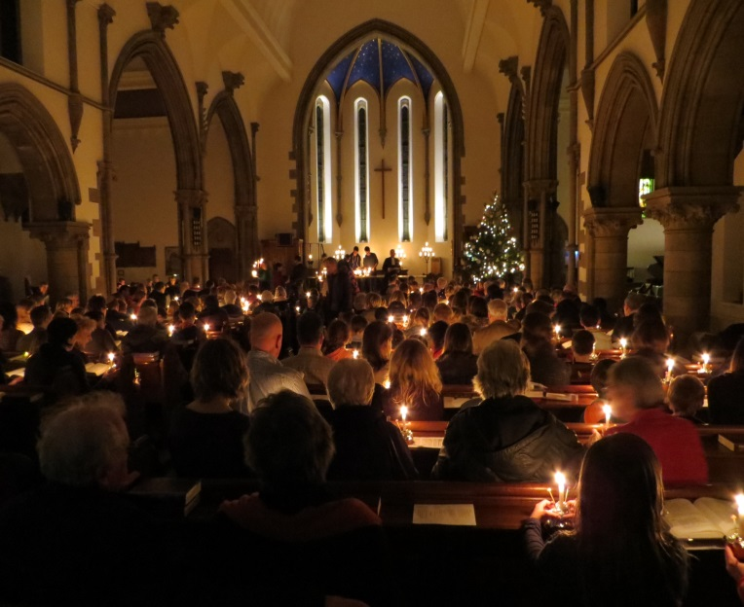

Science in Worship
During this “age of discovery” in biology and physics it seems that we are being overwhelmed by a wave of secularist and atheistic ideas in sources ranging from the national press to parts of the curriculum for pupils in Edinburgh schools. These are in sharp contrast to the response of many scientists who want to bring the excitement, wonder and awe of these new discoveries - from cosmology to neuroscience - into daily Christian living. We consider science to be complementary and consistent with our faith and plan to produce “education” and “worship” material that focusses on themes reflecting the interests of the congregation at different ages. We intend to prepare, both as a booklet and online, material on several topics relating to science and faith and to include therein prayers and reflections for use in Sunday worship and study by groups and individuals. We will evaluate the material in our congregation and anticipate it will be useful for other congregations and interested groups.

Key Questions:

1: “Origins” – What are the methods and boundaries of science and how does science contribute to a Christian understanding of the origin of the universe and the start of life on earth?

2: “Being Human” How do we express our Faith in the light of evolutionary theory and the emerging discoveries in neuroscience revealing the biochemical mechanisms which lie behind cognitions, emotions and beliefs?

3. “21st century Challenges” How can we relate scientific insights to our Christian faith so as to inform current controversy about such issues as challenges to the environment, dying and sexual orientation and the rapidly expanding genetic technologies that impact on the environment, animal welfare, health and what we eat?

4: Worship – How can we introduce the vocabulary of science into everyday worship through prayers, reflections, biblical interpretation, hymns and relevant quotations from scientific writing?

